Delivergrid

A Development Suite for Motion Planning (Shortest Path) Puzzles

Brian Vacek
BrianVacek@gmail.com
1.0 Abstract

This paper lays out the development of Delivergrid, a suite of development tools for designing motion planning (shortest path) puzzles. It describes the design and implementation of Delivergrid, provides an instruction manual and describes the algorithms found in the code.

2.0 Introductions

Motion planning for robotic agents is a field of algorithm design that is very complicated to implement in the field where obstructions may be an infinite variety of size and shape. To solve shortest path problems, approximation is often used, frequently based around PRM (probabilistic roadmap) algorithms adjusted or optimized for a specific function.

In the puzzle game world, such approximation is rarely allowed. Puzzles are usually deterministic and must have an exact, final solution. Thus Delivergrid is built around a standard simplification: the grid. Location is restricted to squares decomposed from a larger environment, and movement is restricted to 8-way travel. The grid-based board is the foundation of the Delivergrid toolkit.

The basic concept behind Delivergrid is to provide game designers a variety of tools and options to build grid-based shortest path puzzles and simulations. To accomplish this task, eight basic types of squares can be applied to the main board to build puzzles. These include the obvious defaults of open space and obstacles (hereafter called walls) as well as special pieces such as jumps, teleporters, one-way arrows and others. Each type of square is distinguished by color and/or number (sometimes a symbol).

One of the most important varieties of square is the goal terrain. The task of the player trying to solve the puzzle is to reach all of the goals on the main board in the minimum amount of distance traveled (trying to beat a target distance set by the creator). Solving the puzzle may involve numbering the goals in the best order to visit them and/or using a variety of inventory items to create a superior route.

3.0 Related Work

Shortest path problems with multiple goals have been around since before robots even existed and have applications in delivery problems (such as mail) and routing problems (such as traveling salespersons). For grid-based simplifications such as the one used in Delivergrid, common methods include Approximate Cell Decomposition and Navigation Field Techniques. The former does not apply to Delivergrid, since the puzzles start and end as an abstraction and do not really rely on a real-world dataset. The latter method, particularly its expanding waveform paradigm, is highly relevant and will be described further in the Methods section.

For multiple unordered goals, the problem is related to the traveling salesperson problem (TSP): in a graph in which all the nodes are connected and weighted, what is the lowest weight path that visits every node and returns to the start. The difference here is that we do not need to return to the start. TSP is an NP-complete problem. The solution used by Delivergrid is a variation on the HeapPermute recursive function designed by A. Levitin in “Introduction to The Design & Analysis of Algorithms” (pg 179).

Similar games have been designed and distributed in the past. Often these involve pushing boxes (or boulders) to clear a path, an application that is not attempted by Delivergrid because a dynamic environment could not be solved deterministically at real-time speeds. What distinguishes Delivergrid from other puzzle games is the ability for users to design their own puzzles and use a variety of special pieces and additional functionality not generally available.

4.0 Proposed System

4.1 Premise

The idea behind Delivergrid was to create a 2-in-1 application that would allow users to develop their own puzzles with a large, scalable suite of tools and then to turn around and test the puzzles or distribute them to casual players (who may or may not have interest in developing their own puzzles). The design and testing tools should be easy to use, with much of the complexity either eliminated by the interface usability or handled internally by the computer.

Delivergrid is designed for the PC and was developed in VB.NET. The user interaction is based around a two-button mouse. The code is organized in such a way as to be easily extensible for future additions or modifications. Clarity is important when studying the puzzle board, and so color coding and numbers/text are used to distinguish squares.

4.2 Requirements

- To design a suite for creating and playing grid-based motion planning problems.
- Allow multiple goals.
- Allow player to solve ideal order for visiting goals or to have the designer set a strict order.
- Write an optional AI that can solve the minimum path, report the distance and show the route.
- Create a suite of interesting special squares to complicate the puzzles.
- Keep usability in mind so that players can design their own puzzles easily.
- High scalability for adding new special pieces or ideas.
- Allow puzzles to be save/loaded for easy distribution and puzzle reuse.

5.0 Developed System

5.1 GUI

The GUI for Delivergrid is designed to allow high-functionality and ease-of-use at the same time. It can be used for creating puzzles (in Edit Mode) or testing/playing levels (in Play Mode).

An overview of the GUI is shown below:

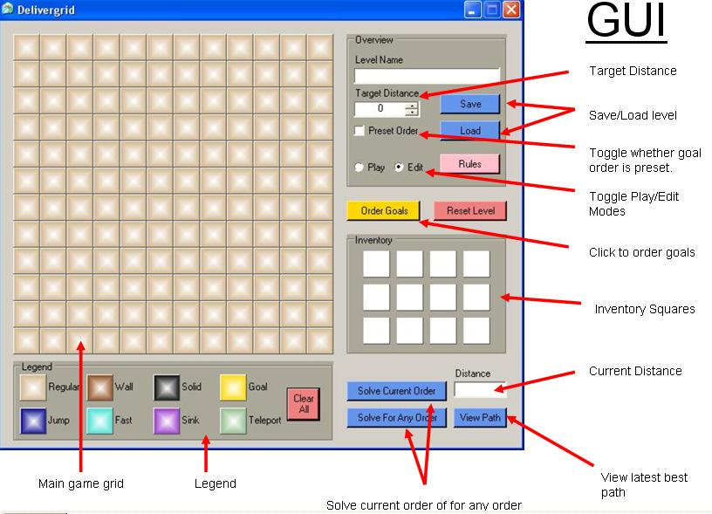

[Figure 1: GUI Overview]
5.2 Instructions

5.2.1 Basic

The goal is to get a robot to visit all of the goals (yellow squares) in the lowest total distance. To win a level, you must find a route that is equal to or less than the number listed as the “Target Distance.”

Moving to adjacent squares costs 1, while moving diagonally costs 1.5.

5.2.2 Finding the Best Route

If “Preset Order” is not checked, then the goals can be visited in any order. The player can number the goals in the desired order by clicking on the “Order Goals” button and then clicking on the goals in the order they wish the robot to visit them.

If “Preset Order” is checked, then the goals must be visited in the preset order.

Pressing the “Solve Current Order” button will find the minimum distance for visiting the goals in the selected order.

Pressing the “Solve For Any Order” button will find the minimum distance for visiting the goals in any order (only for eight goals or less).

Pressing the “View Path” button after solving for the minimum distance shows the robot (in red) traversing the minimal path.

5.2.3 Special Pieces

Name: Regular
Color: Light Brown
Rule: Open space where motion is free. Default terrain type.
Special: Regular squares can be given seven special characters (^ > v < | -- +). The four arrows force the robot to make their next move in the direction they point. The vertical and horizontal bars force the robot to make their next move only vertically or horizontally, respectively. The plus sign forces the robot to make its next move only to adjacent squares (no diagonals).

Name: Wall
Color: Dark Brown
Rule: Can not be moved onto.
Special: If the wall square is numbered, the robot can move onto the square, but only by paying an immediate extra distance cost equal to that number.

Name: Solid
Color: Black
Rule: Like a wall, but can not be erased even by inventory items.
Special: Same as wall.

Name: Goal
Color: Gold
Rule: Each goal must be reached by the robot before the path is complete.
Special: The numbers given to the goals correspond to the order they will be visited.

Name: Jump
Color: Dark Blue
Rule: The robot can leap from a jump square horizontally or vertically by a number of squares equal to the number on the jump square for the cost of 1. It can choose not to take the jump.
Special: None.

Name: Fast
Color: Turquoise
Rule: Moving off of this square is free.
Special: If the fast square is numbered, the regular cost of moving off of the square is divided by that number.

Name: Sink
Color: Purple
Rule: The robot can teleport to a sink at any time for the cost of 1.
Special: If the sink has a number on it, the cost to teleport to the sink is equal to that number.

Name: Teleport
Color: Green
Rule: From on a teleport square the robot can go immediately to any other teleport square on the grid for the cost of 1. It can choose not to take the transporter.
Special: If the teleport has a number, the robot can only go immediately to other teleports with the same number. It can still choose not to take the transporter at all.

5.2.4 Inventory

On the right side of the screen are twelve inventory squares that a player can place on the board to improve the minimum path of the robot. Each item can only be used once. To reset the level to way it started before any items were used, press the “Reset Level” button.

Non-regular inventory items can only be placed on unmarked regular squares. However, a regular square in the inventory can be used to clear away non-regular squares on the board (except for solid and goals, which can never be moved or destroyed).

5.2.5 Edit Mode

Edit Mode allows the player to construct levels, try out test cases and experiment with the special pieces. To activate, select the “Edit” radio button. To deactivate, select the “Play” radio button.

While in Edit Mode, the user can click on the squares in the legend (bottom of screen) and then apply them to the game board or the inventory. To add or change numbers on a square simply left-click (increase) or right-click (decrease) on it. To remove an item from the inventory, right-click on it an extra time.

To clear the entire screen, press the “Clear All” button.

In Edit Mode you can also select whether the level will be have a preset order by checking or unchecking the “Preset Order” box. You can set the target distance with the “Target Distance” textbox or arrows.

To save a configuration press the “Save” button. To load a previous configuration, press the “Load” button.

5.3 Examples

In Figure 2 below, you can see an example puzzle that has already been constructed. The puzzle uses only regular squares, walls, goals, directional characters and two jumps. Since the player has no inventory items, the only requirement is that they order the goals in the optimal order.

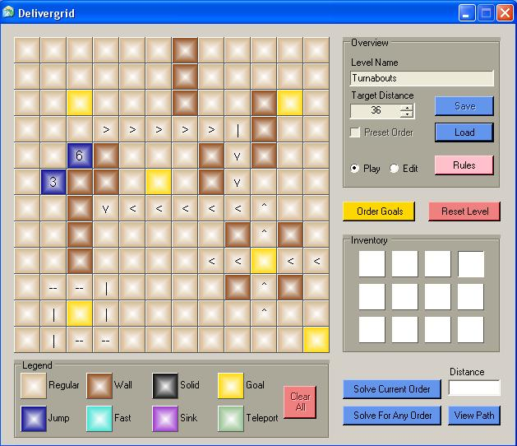
[Figure 2: Example puzzle with no inventory items]

In the next example (Figure 3), we have a puzzle that requires the player not only to order the goals, but to place four inventory items as well: a regular square, a sink and two jumps. We can see the best-known solution to the puzzle in Figure 4. When inventory items are involved, there is no longer any guarantee that the solution is optimal (explained further in the Methods section).
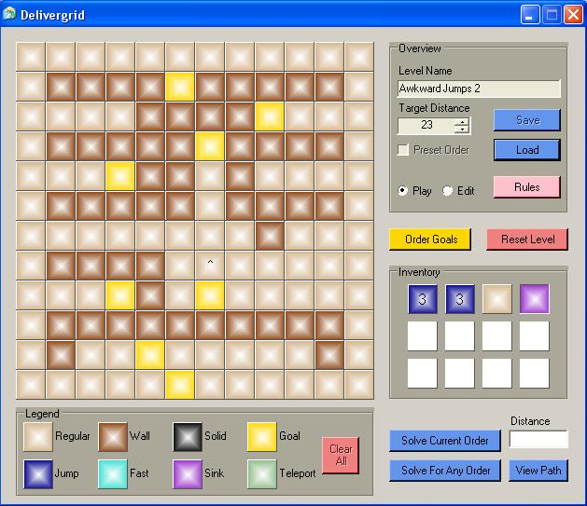
[Figure 3: Unsolved puzzle with inventory items]

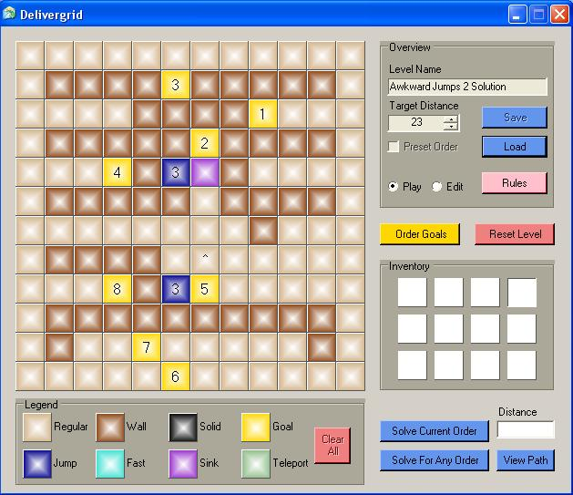
[Figure 4: One solution to the puzzle in Figure 3]
6.0 Methods

The most basic problem that Delivergrid has to solve is the shortest path between any two given goals. Using the expanding waveform concept from Navigation Field Techniques, Delivergrid calls a recursive algorithm that runs a depth-first search (DFS).

The DFS has been modified to take into account the special circumstances of Delivergrid’s system. Not only is the minimum distance to reach each square recorded, but the parent square that provided that minimum distance is also recorded. This allows the algorithm to easily reconstruct the optimal path afterwards by starting at the last goal and tracing upward from parent to parent.

The DFS also accounts for the special squares, limiting the choices of movement in the case of the one-way, two-way and four-way signs or adding to the choice of movements for jumps and teleports. The cost of moving may also change, as when going through numbered walls or using fast squares. It can be proven that if a sink will be used to get between two goals, it will always be used as the first move, so the DFS runs the option of using each sink only once for any pair of goals.

When the order has been defined for multiple goals either by the player or the puzzle designer, the algorithm simply uses the DFS to find the shortest paths between each successive pair of goals and then sums the distances and concatenates the paths. The overall optimal path is saved and can be played back at any time.

When the order is not defined or is defined incorrectly (for instance, with a goal left out), the program can not solve the shortest path problem in the usual way. The problem of solving the optimal route regardless of the order is equivalent to the Traveling Salesperson Problem (TSP) which is NP complete (can not be solved in polynomial time). Since many designers, players and testers may want to see the TSP solution even if there is a time delay, Delivergrid includes a limited capacity TSP solver.

The TSP algorithm first creates a list of all the permutations possible for the current number of goals using A. Levitin’s “HeapPermute” method as the underlying base. It then creates a look-up table of the minimum distances between all possible pairs of goals to prevent running the DFS redundantly. Finally, these two items are combined by using the look-up table values to solve the total path length of each permutation. The minimum is found and re-run to record the actual path.

The biggest limitation in deterministically solving the puzzles is taking into account the inventory items. To solve this problem, every possible combination of how the inventory items could be used would have to be run. This would increase the time complexity of the TSP problem by a factor of n^m where n is the number of grid squares and m is the number of inventory items. Such a problem could not be solved in real-time and so has not been implemented.

7.0 Experiments

The first set of experiments was designed to test the functionality of Delivergrid with only open space, walls and two goals. This test succeeded and variations showed that it could intelligently determine when to move diagonally.

The second set of experiments tested multiple goals that had been numbered by the player. The only significant problem was that the goals between the first and last were repeated when the path was viewed. This was fixed by eliminating adjacent repetitions of visiting a square (it can be proven that no practical case of staying in the same position exists).

After confirming that the basic play mechanics were working, the special pieces were added to the program one by one and tested individually. After some debugging, they behaved as expected. Safe guards for moving out of the grid boundary or onto a wall/solid square were already in place from earlier testing and applied equally well to the special pieces. Once all the special cases were in place, several puzzles were designed for real life use that required multiple special pieces working in tandem. These puzzles, and their solutions, passed successfully and have been saved for demonstration purposes.

A final set of tests was run after the TSP solver was implemented. Since this was the most complicated area of the code and the most algorithmically complex, it took some time to confirm that the code was bug-free and that the solutions were optimal. Using simple tests and progressively complicating them, the answers were confirmed. Interestingly, the TSP solver would often beat solutions (or find alternatives) that had been manually set on previous puzzles, proving its superiority.

After making experimental tests on a variety of data sets, a TSP cap of eight goals was determined to be a practical cutoff to balance functionality and time delay. Eight goals create 8! (approx. 40,000) permutations, which can be solved by the current algorithm in 1-2 seconds. Puzzles can still be designed with any number of goals, but the TSP solver will not attempt to run on cases with more than eight.

8.0 Conclusions

Delivergrid, while not comprehensive, succeeds as an important first step towards a puzzle development suite. The variety of functionality already introduced far outstrips most similar free toolkits available online. Though light-weight relative to most game development environments and engines (primarily due to its graphical simplicity), Delivergrid manages to allow gameplay variety and puzzle complexity that make it suitable for online distribution, amateur puzzle development and motion planning simulations of simplified real-world problems. The shortest path algorithms (both ordered and TSP) have been proven correct in a variety of experiments where manual confirmation is possible. Both run at speeds that are suitable for real-time use.

9.0 Further Work

The intention of Delivergrid from the very beginning was to leave it open for future development and modification. The eight types of terrain available for the grid as well as their special options were designed not to be comprehensive, but to demonstrate the possibilities for both puzzle and simulation purposes. It is hoped that many designers with creative ideas will feel free to write modules for new squares and new functionality.

Algorithmically, the TSP solver could use optimization for both speed and workload. The approach taken for this version is fairly naïve, using neither branching nor bounding to prune the permutation list. The permutation list could also be computed in advance and stored in a lookup table for systems where memory is not a constraint. If a TSP solver could be implemented that solves up to 20 goals at pseudo-real-time speeds, almost every practical puzzle could be solved.

Another limitation encountered was the inability to find the optimal placement of inventory items algorithmically due to the time complexity. A solution to this problem could be found by optimizing a deterministic algorithm, but a more practical idea would be to use heuristics to approximate the best placements.

For simulations that come closer to real-world representations, the resolution of the grid could be increased. As for the market value of Delivergrid as a puzzle game, a series of progressively harder levels could be designed and sold or distributed online. Interesting multiplayer versions could also be adapted where players would be required to use strategic or combative placements of inventory items to compete while under time constraints.

10.0 References

Cormen, Thomas H., Leiserson, Charles E., Rivest, Ronald L., and Stein, Clifford. Introduction to Algorithms, Second Edition. MIT Press and McGraw-Hill, 2001. ISBN 0-262-03293-7. Section 22.3: Depth-first search, pp.540–549.

Davis, Gavin, Dynamic Labels for Grid-Based Game Design, 2006

Gutin, G. and Punnen, A. P. (2006). The Traveling Salesman Problem and Its Variations. Springer. ISBN 0-387-44459-9.

Levitin, A., Introduction to the Design & Analysis of Algorithms, Addison Wesley, 2003, pp 179

